**PROJECT REPORT**

**On**

***IT Asset Management & Tracking System***

**SUBMITTED TO THE**

***DIRECTORATE OF DISTANCE & CONTINUING EDUCATION***

**IN PARTIAL FULLFILLMENT OF THE BACHELORS IN COMPUTER APPLICATIONS (General)**

***by***

**Name: Pruthvirajsnh Jagdishsinh Chauhan**

**University Roll No: …………………………….….**

**En. Rollment No…………………………………….**

**Regn. No…………………………………………….….**

Under the

Guidance of

**Name of Internal Guide : Mr. Divyesh Shejwani Name of External Guide**

Designation : Designation

**CERTIFICATE OF THE GUIDE**

**Mentor / Guide Name:**

**Designation:**

This is to certify that the project report entitled “_____________________________ _________” has been prepared by Ms./Mr. under my supervision and guidance, for the fulfillment of Bachelors In Computer Applications. His/Her field work is satisfactory.

**Date: Signature of Guide**

**ACKNOWLEDGEMENT**

I convey my sincere gratitude to AGM (HR)/_______________________ for giving me the opportunity to prepare my project work in___________________________ . I express my sincere thanks to all the staff members of_____________________ .

I am thankful to______________________________ for her/his guidance during my project work and sparing her/his valuable time for the same.

I express my sincere obligation and thanks to all the Faculties of DR.BAOU ___ ______________________ for their valuable advice in guiding me at every stage in bringing out this report.

**Name:**

**Roll No:**

**DECLARATION**

I do hereby declare that this project work entitled “ _____________________” submitted by me for the partial fulfillment of the requirement for the award of Bachelors In Computer Applications (BCA-General) is a record of my own research work. The report embodies the finding based on my study and observation and has not been submitted earlier for the award of any degree or diploma to any Institute or University.

**Date: Name:**

**Roll No:**

1. Employee
2. TST
3. TST Administrator
4. IT Manager
5. Employee

* Send the request – (Items: New > change > Others)
* Read the request – (Status: Read > In-progress > in-approval > Approved or Reject)
* Close the request – (Finish)
* **Lodge the complaint**
* Status of the complaint
* Close the complaint

1. TST – Technical Support Team

* Receive the user request – (Items: New > change > Others)
* Read the request – (Status: Read > In-progress)
* Send to TST Admin (for purchase process to Admin, **in-approval**)
* TST Admin (Floating inquiry and make comparison for IT Manager approval)
* TST Admin send request for approval from IT manager.
* **Receive the user Lodged complaint**
* Read the complaint & working on same and update status (Status: Read > In-progress) if require
* Forward to TST Admin (if enhance team support require)

1. TST Administrator – Technical Support Team

* Receive the request from user – (Items: New > change > Others)
* Receive the request from TST team Member – (Items: New > change > Others)
* Working on the request – (Status: Read > In-progress > Resolving stage)
* Allocate & Handel the requests and complaint (priority wised) (Low_Medium_High)
* Monitor TST all Request & complaint.
* Send request & complaint to IT Manager (for purchase, Repairing & other work approval)

1. IT Manager – Head of the Technical Support Team

* Receive the request from users – (Items: New > change > Others)
* Receive the request from TST team Member/Admin – (Items: New > change > Others)
* Monitoring & Process the request – (Status: Approved for purchase – Release, Finished)

**USE CASE DIAGRAM**

**Employee**

**USE CASE DIAGRAM**

**TST – Technical Support Technician**

­

**USE CASE DIAGRAM**

**TST – Technical Support Technician -ADMIN**

1. What is the existing system?

Existing system means it is presently using system or systems that we are not going to use further in our working environment.

System which is used to maintain IT related information i.e., peripheral details, software details (Validated & Freeware), raise request of the new requirement, change/replace of the items, receiving of peripherals or items, allocating of the computer systems, parts or any other items and software to users. Generating asset code for companies own purchased assets and tracking of asset whether it is in working condition or not (Active or Inactive), viewing report and reporting to the management.

In addition to above renting services are also used by the various companies and to manage renting assets and tracking of the record for same products which will be added one more responsibility to the management and technical team members, i.e. also need to manage properly like (Renting product :- Desktop, Laptop, Printers, projector and any other accessories). Presently that is also managed in separate MS Excel file or in various tabs in one excel file.

Maintaining of record for renting services products & AMC services products also, which is essential for the team which can appear proper management and record system. Instance:- Records of renting or AMC provided printers in that case need to manage Page count report (A4, A3, Single side & duplex side prints, if copier then copies also) for verifying monthly billing which is generated by vendor.

Above mentioned all process are presently maintained in **MS Excel** which is part of **MS Office application package**. Managing this existing system based on manually entry only in organization.

It is taking more time to making of new entries due to long formatting of sheet, viewing of more columns format also taking time to manage via the scrolling action (Left, right & up, down).

It has increasing the work & time while need to generate any categories report on time to time bases, in that case we have to maintain various tabs to edit, remove & hide items before reporting. And in some cases it is require to move in new file or sheet to generate report. In few cases while report send to the non-editable format then again has to convert in PDF file, so finally this existing system has time taking activities. In this system many more tabs create because if we updating on the same sheet in same data, in that case we didn’t get the old details so this process has increasing more work and manually activities also consume time.

It is not automated manageable system, now a days in the globe there are lots of new technologies alongwith new platforms to maintain and manage various kind of above described process, where we can say good bye to old and manually working technology and need to utilize newer technology to maintain and manage standardized system which can be lesser time consuming, easy to manage (Add, Update, remove & data backup), easy to use for all (end users and managerial levels).

1. Define its scope.

IT Asset management system is developed to provide smoothly, standardized, well organized data and easy to tracking of assets digitally using the electronic management system from centrally at one stop by the users (employee & guest) & Admins.

It has also consist record, tracking of request & complaint to the users from the one login solutions. Where users (employee & guest) and admin can interact along-with their provided rights in interfaces.

Features of IT Asset management system are as follow:-

* Management of physical components from acquisition through disposal including desktop, laptop, servers, LAN & WLAN electronics, wireless devices, voice and communications equipment.
* Software License management.
* Standardization of contractual compliance.
* Record & tracking of requests
* Record & tracking of complaint
* Asset availability.
* Asset compatibility.
* Current assets users.
* Asset history.
* Authenticate the user (employee/guest) & administration.
* Administrator can generate a unique id (Asset Code) for every asset.
* System can auto generate a unique id for every request & complaint.
* Administrator adds details of the new asset into the database, remove details of the asset that are obsolete from the data ase and moved to the assets history database.
* Administrator can create new vendors, add vendors, update details of vendors.
* Identify the user who failed to comply assets policy (damage or loss). Send a message to the user.
* Assets can be returned.
* Updating the table accordingly for every transaction.
* Creating reports for transactions that are committed on basis of day/month/year.

1. How the existing system work?

Here existing system work through manually data entry system, and to maintain all record from users request to disposal of items managed in Excel sheet.

We have separate tabs/sheets for maintaining different types of data via creating various types of format as per our requirement and time to time we are updating the all format and maintain data.

In this using system there is no any database it is purely manage on file system only, where we have to take data backup via saving files from various dates and which is creating multiple files time to time.

In this MS Excel based file some time we have faced corrupting of file issues and it will not recoverable many times, in that case again we have to update current date data in available existing dated old file in any other location in computer system or in over the server or cloud backup.

For new request & complain manually system is using via e-mail or using phone services. It is non ticketing system.

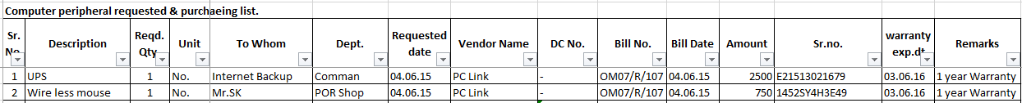IT TST & Admin once received the request for any item then put entry in one excel sheet as per below format every time, after received item few details related to that like vendor name, delivery challan number, invoice number & date, amount, serial number & warranty expiry date.

IT local team send request to HO for each and every request related to purchase via email and after approval of the same can order to vendor and received the item. In case the product is fixed asset then admin team create asset id and same has to stick on the particular asset to identify and track the same.

Allocating of assets / software / parts / accessories same process are done in excel file adding manually in under format which can help to understand more deeply

In this system there is no serially record maintain because some time user are requesting on phone and if admin has busy in another work may be forget the request and cannot proceed further for new item request.

Even in renting products details are also managed in excel file only each sheet for each product example :- printer (Model Konica 283) separate sheet maintain for the same and recording of page count (A4, A3 & duplex) monthly basis and every month after taking out page consumption report from the machine that report should be signed by the department persons and IT team and send to the vendor for further billing purpose.

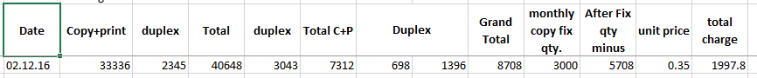

Record maintain in the above kind of format to track previous record and to get help to certifying of invoice in lesser time.

In presently system local vendor management list is not available, it is manually in excel sheet and if need to create purchase order to the vendor first colleting data & documents from the vendor i.e. government registration certificate, GST Registration, Pan card, MSME registration details if registered, bank details, cancelled cheque, contact person name & number and send request to the head office for new vendor code creation in SAP.

SAP system is using for creation of purchase order presently. But here lots of items which are purchased without purchase order at the location and for that we have no system to manage purchase order request & vendor details.

1. What are the issues/problems with the existing system?

In this existing system we can manage data but it is not based on any database system where data has mange smartly and where backup option are available of that filled data in database tables.

Here in this working system everything is managed by applications like excel & word. This is the application and need to create new files for all kind of various activities data management.

It is not creating auto mated report for the file and every time need to generate / create report as required.

In the system for maintain various types of items information all various formats has to maintain, and major issue are facing while need to generate report in various categories, in that case generate more sheets or more files as per required report.

It is increase more files, more tabs in one file in computer and if file has damaged by virus, failure of HDD or any other reasons, some time very hard to recover file data and file.

Loss of file and damage of file chances are high and recovery chances are low in the existing system.

No vendor management system available, hard to track vendor details.

Allocating of products to the user are manually and updates are manually every time even there is no itimation system after allocating of items to the users.

Tracking of the allocated assets are not easy and more files are need to refer and papers to be checking.

1. How are you going to improve on the issues/problems with the existing system?

Existing working system are manually based system which details are available above and this project has developing by us to provide solutions of the existing system in favor of smart process & improvement in system.

We will developed new application to solve existing system issues and i.e. application/software will developed in .NET platform. Using database system to manage data via MS SQL Database server. In this new system there are separate module has created and according to that activity process will be work to understand the user and IT team to work with the system smoothly.

This new system is providing by URL link using intranet where user and IT team can use this application/software in browser there is no more externally application to be procure and deploy at the end. Browsers are available free ware where cost is not involved. Mainly in this developed system users will interact with attractive graphically dashboard where users can view graphically data on the page including graphs, colors tabs with details as per modules.

Users can get login details, so authentication and authorization are included in system for security aspects. Unauthorized user will stop to using system automatically. IT Administrator can manage users & technician’s roles and rights which is not available in existing system.

This system can manage user requests and save all the requests details in the database which can user will view and check its status mode. Even though we have added complaint booking system in developed system to manage & maintain all complain where system can generate complain number to view and tracking of the complain. This can help to improve technical team performance and store the complain details which can help to resolve same kind of complain to other team members. According to this it can show performance of the IT team case wise resolutions which will help to monitor and measure of performance of team.

In developed system all various types of data properly managed and details of received items, allocated items, removed items & software details including assigned software’s to users.

Managing users / employee requests are the newly added features in the new system where admin team can manage the users via creating id, new password, resetting of user & technical team member password. Employee request are also important and recordable module in the new system where user can manage requests via status i.e. Read, In-progress, resolved and close the request.

Major added and highly effective module is reporting module where IT technical team member can view customize reports and also export the reports instance active system, non-active system, category wise report user wise , systems wise, software wise & peripheral wise.

Where IT Admin can view the above category wise report and more added report facilities i.e. vendor report, technical team performance report via resolve cases number wise and time wise, assets reports along-with assets details using generated assets codes.

Backup & restore facility has added in new system where we can do the backup of data and restore the backup as an when require in cases of loss of data, reinstallation of software, failure of hard disk or any other reasons. This added features will help to secure data as a backup & restore facilities which is not available in existing system. This improvement can help to saving time and providing restoring data backup option.

Improved system has deploying after passing of testing phase by testing team where all functionality has checked and verified by the team & requester of software users, which will help to prove successfully working of application/software.

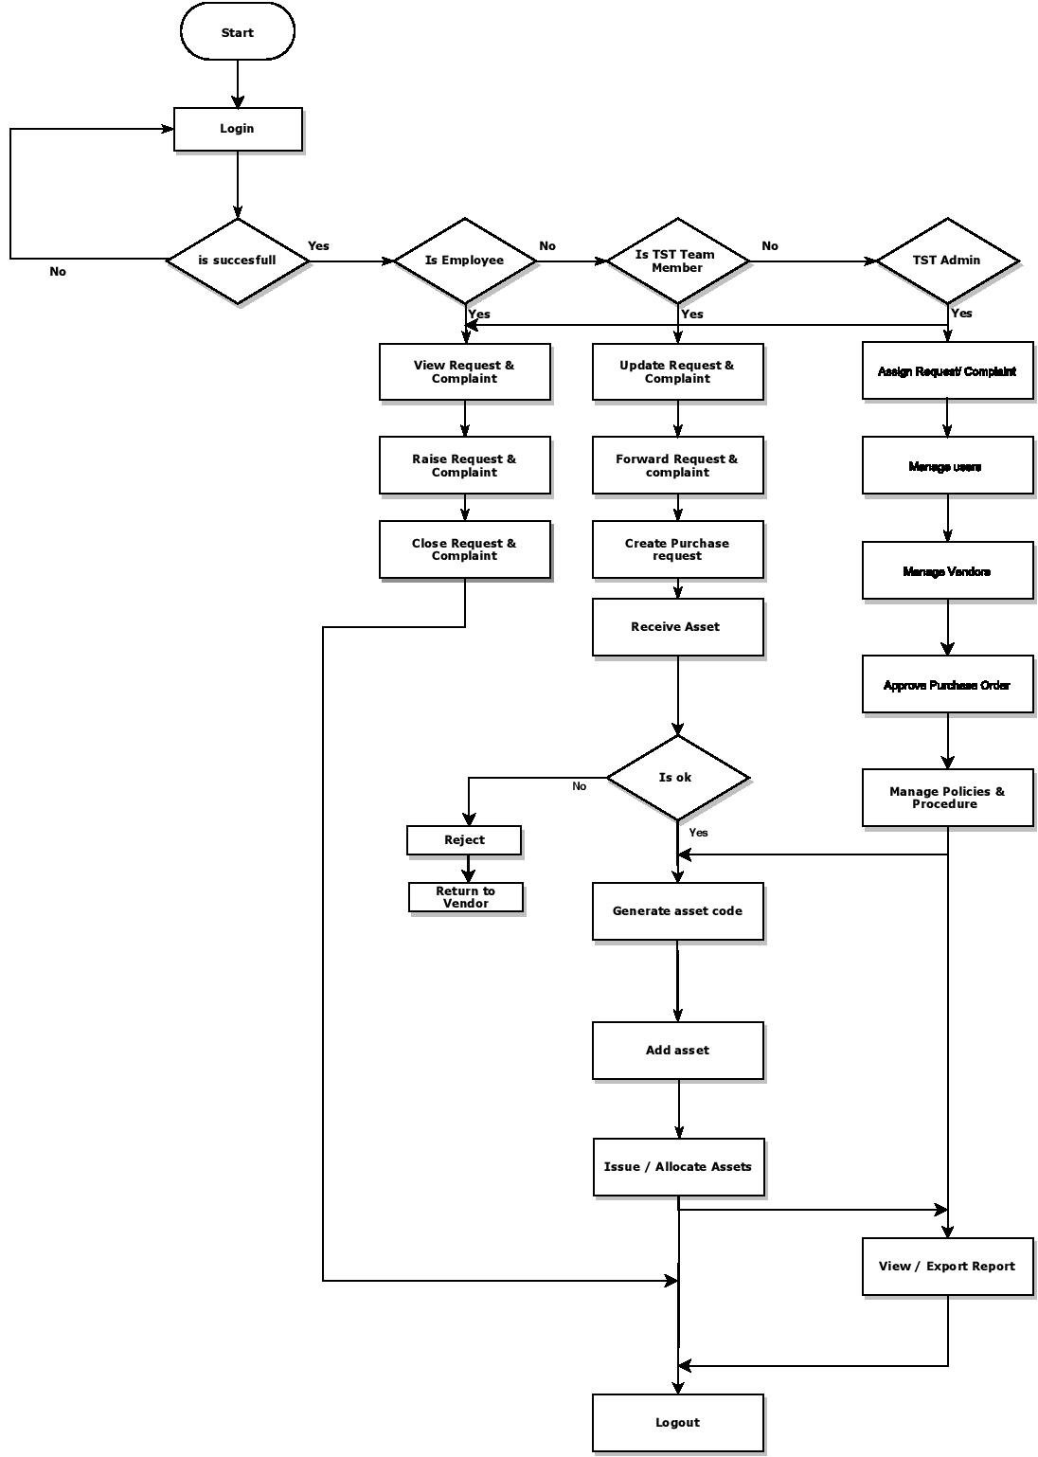SYSTEM FLOW CHART

Flow chart, Data flow diagram & context

ER Diagram